Design and Synthesis of Supramolecular Liquid-Crystalline Assemblies
Formed by Multiple Noncovalent Interactions

Junko Macro,¹ Taro Kobunshi,² Takashi Kato^{1, 2}

¹School of Engineering, The University of Tokyo, Hongo, Bunkyo-ku, Tokyo 113-8656, Japan
²Research Institute of Polymer Science, Kobunshi University, Irifune, Chuo-ku, Tokyo 104-0042, Japan
¹E-mail: spsj@fmail.com

Type text here. Self-assembly of liquid-crystalline (LC) molecules has attracted much attention because it allows development of a variety of functional materials (1, 2) …………
Please write the abstract after removing the example texts.
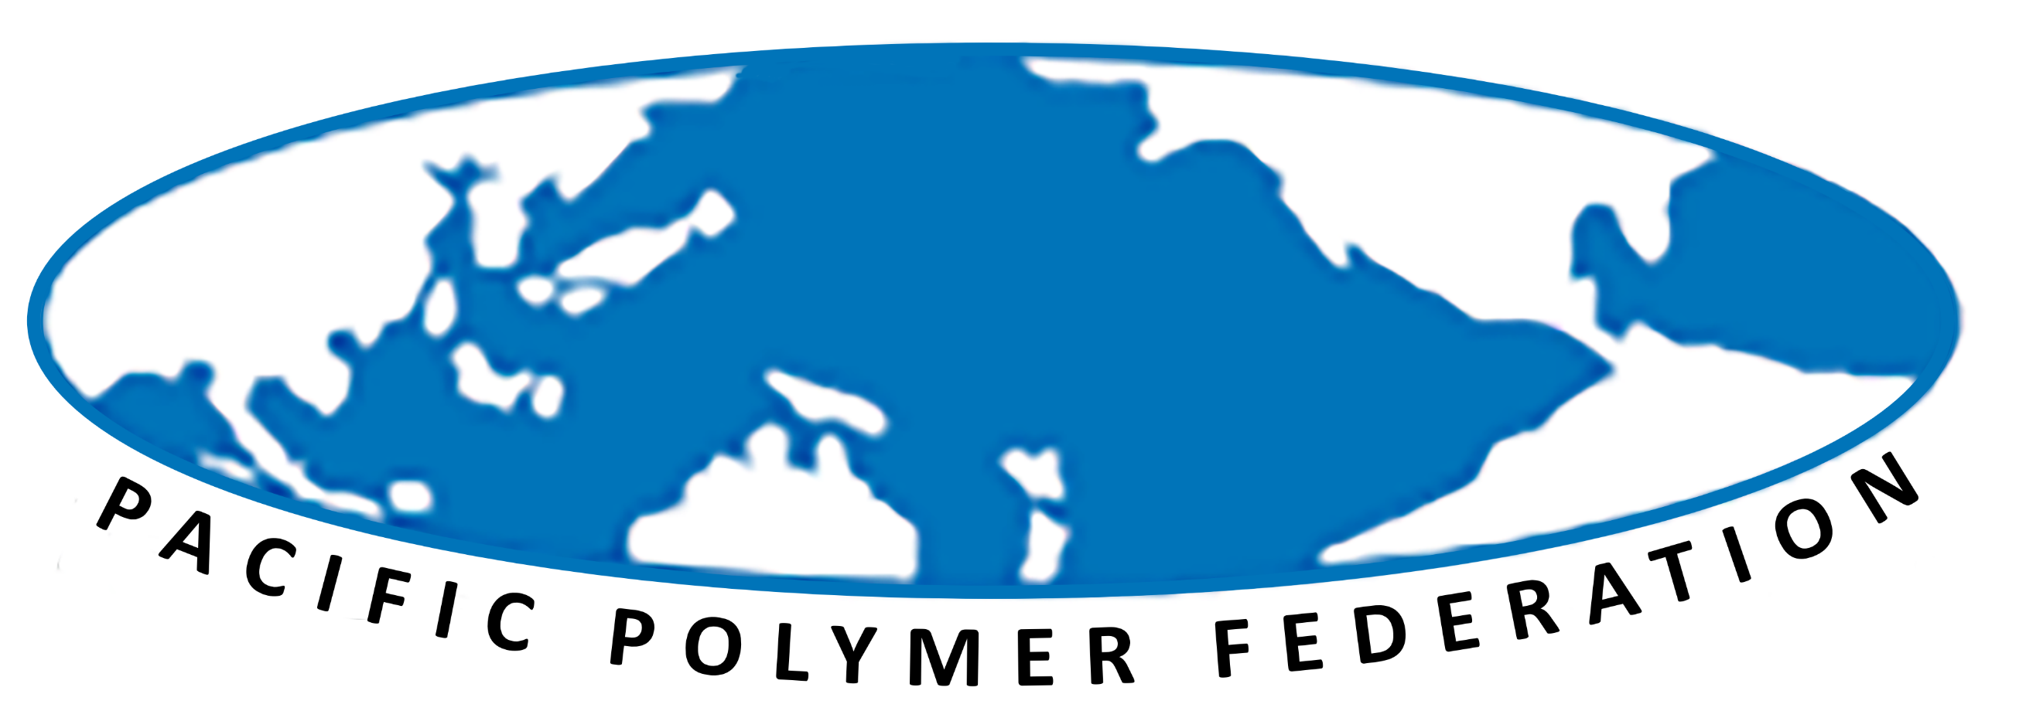
…………………………………………………………………………………………………………………………………………………………………………………………………………………………………………………………………………………………………………………………………………………………………………………………………………………………………………………………………………………………………………………………………………………………………………………………………………………………………………………………………………………………………………………………………………………………………
Fig.1 Logo of PPF.

Length and Size: single A4 paper (297mm x 210mm) including text, tables, figures, photos, caption, and references with 30-mm margins at top, bottom, right, and left
Fonts: Times New Roman
Title: 12pt, bold, center alignment and capitalized in the first letter of each major word
Authors: 10pt, center alignment, authors separated by comma, speaker’s or poster presenter’s name underlined
Affiliation: 10pt, center alignment, in the order: institution, mailing address with postal/zip code and country
Text: 10pt, single-spaced with indentation at the beginning of each paragraph; no blank line between paragraphs.
Figure Captions: 10pt, appear below figures in the same font as for the main text
Submission: Convert the MS Word manuscripts into Adobe PDF documents and upload to the website.
Reference: 10pt, appear at the end of the abstract, formatted in accordance with examples below

PDF documents are accepted for abstract book.
- The PDF file size of manuscripts must be under 1.0MB.
- Do not cut off the extension(.pdf).
- Please ensure that the PDF is not password protected.
- Embed fonts.

References
1) T. Kato, J. Uchida, T. Ichikawa, B. Soberats, Polym. J., 2018, 50, 149.
2) T. Matsumoto, Y. Shimizu, Y. Nishino, Macromolecules, 2021, 54, 7226.

